Virtual Trainings FAQ

General Training FAQs

What is Oasis?
OasisLMS is the learning platform MACS uses to deliver its training programs. It’s an easy-to-use portal where you can access all your courses, track your progress and build new skills at your own pace.
Certificates of continuing education credits are also available to access in the Oasis platform.

How can I register for a webinar?
To register for our webinars, please visit our Education webpage to see our wide array of trainings on topics ranging from adolescent substance use and maternal health to the management of opioid use disorder, alcohol use disorder and other substance use disorders. Registration is on the MACS Oasis portal.
Oasis is the learning management platform that MACS uses to manage registration, attendance, and continuing education credits for trainings and webinars.
First time registering for MACS webinar? First create an Oasis account by clicking on “Create Account” on the bottom right of the page. Please be sure your name and email are spelled correctly. The name entered will be generated automatically on continuing education certificates. Certificates will be sent via email to the address entered in your Oasis profile.
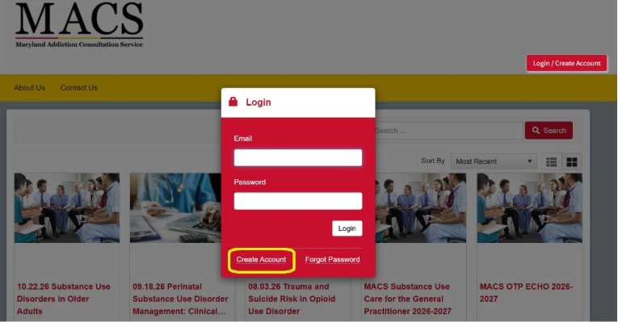
After creating an account, you can sign up for webinars by completing the registration page and pre-course survey for the training you are interested in attending. Each webinar has its own registration page.

I am registered for a training but am having trouble logging into Zoom. How can I get the link?
The MACS team is available to help you log into Zoom to join our virtual trainings. First, we encourage you to check your calendar or email for the Zoom invitation link to join any trainings. It is also available in your Oasis portal.
If you do not have the training on your calendar or in an email invite, please reach out to MACSTraining@som.umaryland.edu or call 1-855-337-MACS (6227).
Please make sure to join the trainings using the same email address that you used to register, otherwise the MACS team will be unable to mark your attendance. We are unable to verify attendance for continuing education if you have not registered for the training.
How can I complete the post-training evaluation for the webinar I attended? And where can I access my continuing education certificate?
Post-training evaluations can be accessed in the Oasis portal and must be completed within one week of the webinar before receiving your certificate.
Certificates are available in Oasis as soon as you complete the evaluation and are sent out via email from MACSTraining@som.umaryland.edu. You must be online for the full duration of the training to access the evaluation. Log into your Oasis portal and click on “My Courses” on the left side. Select the course for which you would like to complete the evaluation and click the green “Continue” button.
After completing the evaluation, continuing education certificates are available to download in Oasis by clicking on “Transcript” on the left side. Certificates are also sent to the email address in your Oasis profile, from MACSTraining@som.umaryland.edu.
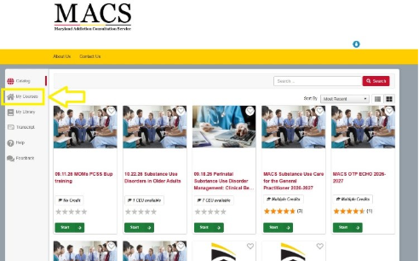

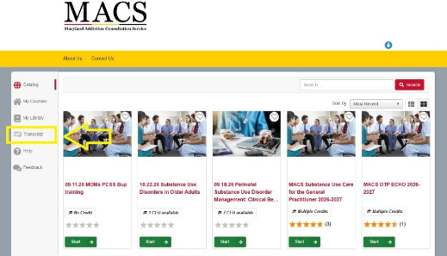

Are all virtual trainings recorded?
We are happy to provide recorded webinars for you to view and refer to on-demand! Any trainings that were recorded are available to view on the MACS Education webpage.
Half and Half MOUD trainings provided in partnership with PCSS-MOUD are not recorded.

I was unable to attend the training I registered for. How do I find out when the next session is so I can sign-up?
We strongly encourage you to stay up to date with our upcoming trainings and ECHO Clinics!
Check out all the ways you can connect with MACS:
- Visit our Education and ECHO session webpages,
- Sign up for our MACS Monthly Newsletter and Education alerts, and
- Make sure to follow us on social media:
  - Facebook
  - Instagram
  - LinkedIn
  - X

PCSS-MOUD Training FAQs
MACS partners with PCSS to offer the Live MOUD Training at times throughout the year. These live, virtual trainings are 4 hours and count toward the DEA training requirement for new or renewing applications. After completing the live training, participants are directed to the PCSS learning platform to take advantage of the up-to-date modules if additional training hours are needed to fulfill the 8-hour requirement. In addition, our virtual trainings and ECHO Clinics are each an hour-long and count toward DEA license registration and renewal.

I’d like to obtain or renew my DEA registration. Does MACS offer programming that counts toward the 8 hours of training on opioid or other substance use disorders required by the MATE Act?
Yes! MACS offers plenty of trainings that help prescribers obtain or renew their DEA registrations and count toward the 8 hours required by the MATE Act.
Review additional information about the MATE and MAT Acts.
A list of MACS Upcoming free trainings, including MOUD Courses can be found on the Education Page on our website.
Check for more information on PCSS 8-Hour MOUD Education Options.

If you have any questions about MACS Trainings, including upcoming events, how to sign up, continuing education credits, or OasisLMS support, please email MACSTraining@som.umaryland.edu and our team will respond within 24 business hours.

